KIT CONTENTS CHECK LIST
When unpacking your HT1ADD Heat Transfer Add-on Kit, check each item to ensure your system is complete.

HT1ADD
1 Room Add-on Kit
Packed by Airflow |  | Tuesday, 28 July 2026 |  |  |  | Unpacked by Owner
 | 1 | HT1ADD # 10 Box  contains the following |  |  |  | 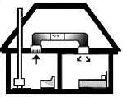 |  | 1 Box  Yes / No
 | 1 | Downjet 150Ø Diffuser |  |  |  | 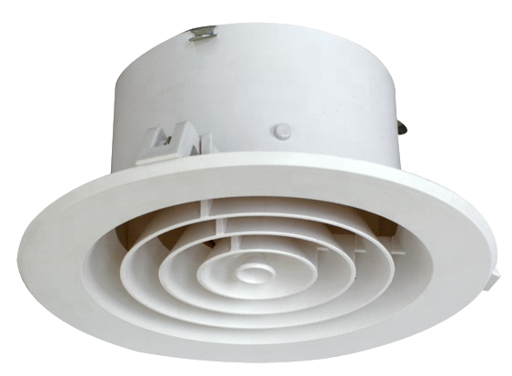 |  | 1 Diffuser  Yes / No
 | 1 | 150Ø 6m Insulated Flexiduct |  |  |  | 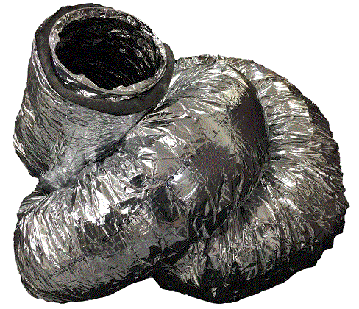 |  | 1 Duct  Yes / No
 | 1 | 150/150/150 Y Branch |  |  |  | 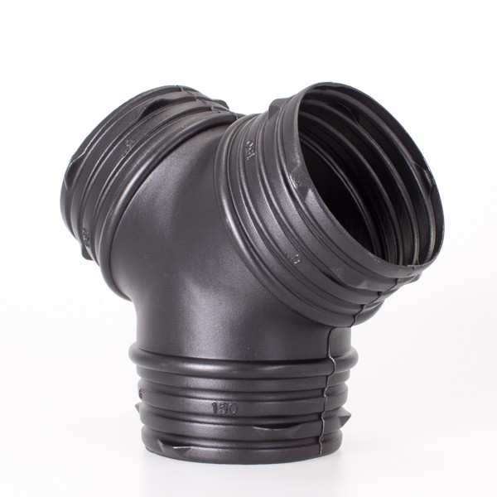 |  | 1 Branch  Yes / No
Packed by:
Checked by:
Tuesday, 28 July 2026



