DATA SHEET

ILC6 1Ø – FläktWoods 315mm Inline Centrifugal Fan
 | SPECIFICATIONS
 | - ILC6 / 315 Inline Tube Fan
 | - Motor: 220 - 240V / 50Hz / 1φ
 | - ILC6 utilises an external-rotor motor and an internally mounted capacitor rated to IP44
 | - Total Motor Wattage: 300 Watts
 | - Sound Pressure Level at 3m in dBA: 49
 | - ILC/6’s are manufactured from plastic materials incorporating metal back plates.
 | - Free Air Fan Performance: 0.48m³/s / 480 l/sec | 
 | - Spigot Diameter: 315mm diameter
 | - Built in guide vanes
 | - Temperature Range: -25°C to 70°C

 | Features | Benefits
 | - Speed controllable | - Enabling control down to 20% of full speed.
 | - Easy to install | - Saves time and money
 | - The fan casing offers circular inlet and outlet connections | - Can be installed with solid or flexible duct
 | - The fan may be run at any angle | - Allows the fan to be placed to suit your configuration
 | - Accessories Available | - Non –return damper, duct mounting clamps, silencers
 | - 1 Year Warranty
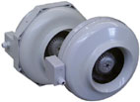
ILC6 315 1Ø 1 of 2 Jul-26



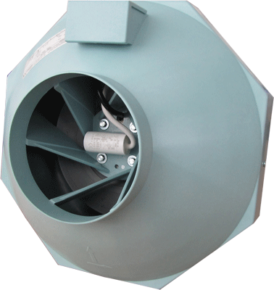
• 315mm diameter inlet/outlet
• Speed controllable
• Up to 480 l/s (1,730 m3/h)
• Multi-functional
• Total pressure Up to 700 Pa (Static)
• Low noise levels
• Durable light weight construction
• 1 year guarantee
• Easy to install


AIRFLOW ENGINEERING have made all attempts to provide accurate and correct information for this documentation, however continuing product development may mean the components, specifications, images and data may vary from that OFFERED FOR SALE. AIRFLOW ENGINEERING does not accept any liability for this.

AIRFLOW ENGINEERING (SI) LTD l UNIT 2 l 3 LANGDONS LANE l NORTHCOTE l CHRISTCHURCH l 8053
PHONE +64 3 365 EMAIL sale@airflo.co.nz WEB www.thehvacshop.co.nz

DATA SHEET
ILC6 315 1Ø 2 of 2 Jul-26

DIMENSIONS & ELECTRICAL DATA

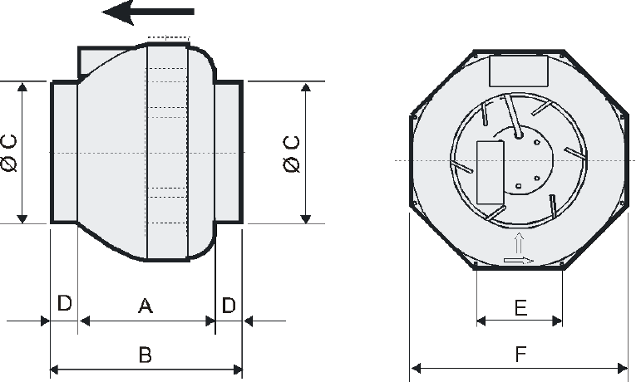
Product  Code | A | B | C | D | E | F | Weight  (kg)
ILC6 | 215 | 275 | 314 | 30 | 160 | 405 | 5.8

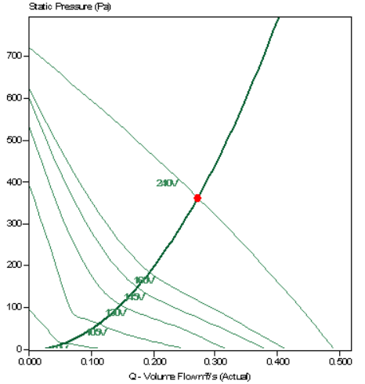

Product Code | Speed | Motor  Rating  (kw) | 220-240V / 50Hz / 1Ø |  |  | Sound  Pressure Levels | Inlet Sound Power Level in dB re 10 pW
Product Code | Speed | Motor  Rating  (kw) | Full Load  Current  (at 230V)  (A) | Starting  Current  (At 230V)  (A) | Speed  Controller | Sound  Pressure Levels | 125 | 250 | 500 | 1K | 2K | 4K | 8K
ILC6 | 2580 | 0.3 | 1.3 | 2.21 | VA500 | 49 | 60 | 65 | 66 | 64 | 64 | 61 | 56
Sound pressure levels quoted are average dBA at 3m distance over a sphere, under free field conditions and are presented for comparative purposes only.
AIRFLOW ENGINEERING (SI) LTD l UNIT 2 l 3 LANGDONS LANE l NORTHCOTE l CHRISTCHURCH l 8053
PHONE +64 3 365 EMAIL sale@airflo.co.nz WEB www.thehvacshop.co.nz

AIRFLOW ENGINEERING have made all attempts to provide accurate and correct information for this documentation, however continuing product development may mean the components, specifications, images and data may vary from that OFFERED FOR SALE. AIRFLOW ENGINEERING does not accept any liability for this.

